

Data Technician

Name:
Course Date:
Table of contents
Day 1: Task 1 2
Day 2: Task 1 2
Day 2: Task 2 3
Day 2: Task 3 4
Day 3: Task 1 4
Day 3: Task 2 5
Dataset: 5
Step 1: Create a Pivot Table 5
Step 2: Use the SWITCH Function 5
Submission: 6
Day 3: Task 3 6
Day 4: Task 1 7
Course Notes 9
Additional Information 10

Day 1: Task 1 ( Skipped – Will be Covered during Azure Week)

Please research and complete the below boxes on common laws and regulations that must be followed when working with customers data, use the below bulleted list to support your answers.

- What is it
- Why is it important
- Provide a real-world example of how you can follow it
- How does it impact working with data
- What could happen if you breached it

Data Protection Act
GDPR
Freedom of Information Act
Computer Misuse Act

Day 2: Task 1

Please research and complete the following tasks within the retail-sales_dataset.xlsx document, paste a print screen into the provided boxes below:

- In the sheet ‘retail_sales_dataset’ add all available data between columns A – H into a ‘table’
- Using the ‘filter’ function, filter ‘Age’ to ‘largest to smallest’
- Using the ‘SUM’ function, show me the commission total in cell ‘P10’
- Using the ‘AVERAGE’ function, show me the average commission in cell ‘P11’

Print screen 1 | 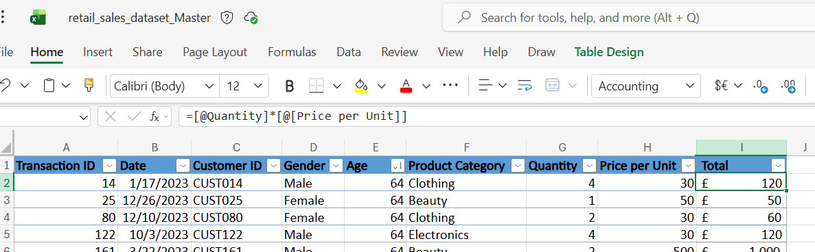
Print screen 2 | 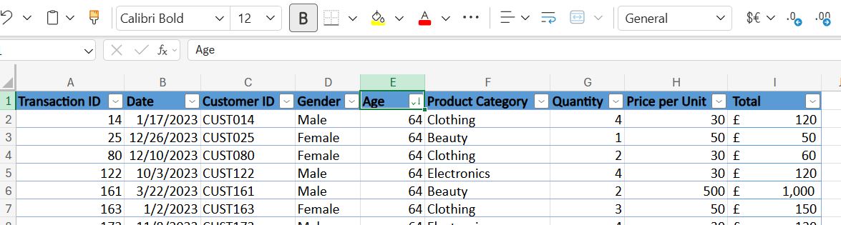
Print screen 3 | 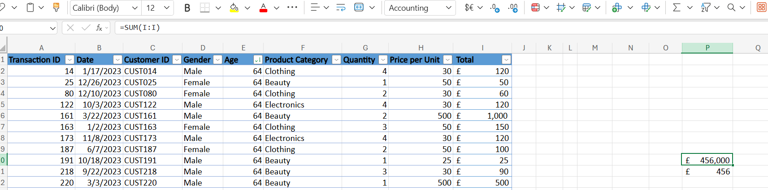
Print screen 4 | 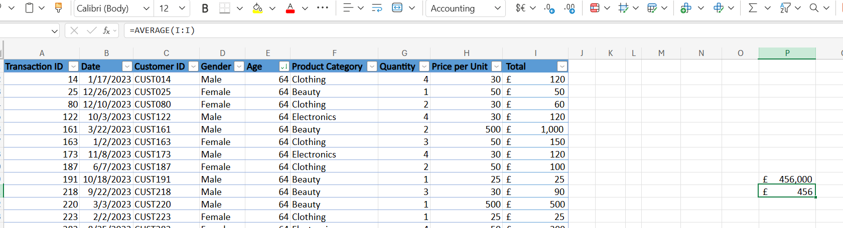

Day 2: Task 2

Please research and complete the following tasks within the retail-sales_dataset.xlsx document, paste print screens into the provided box below:



Print screen 1 | 1) Best students in each subject.  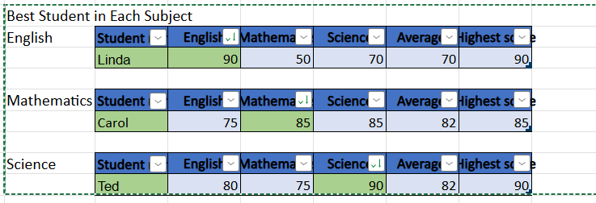  2) Calculate the average for all students and fill into Column E. (Use formula)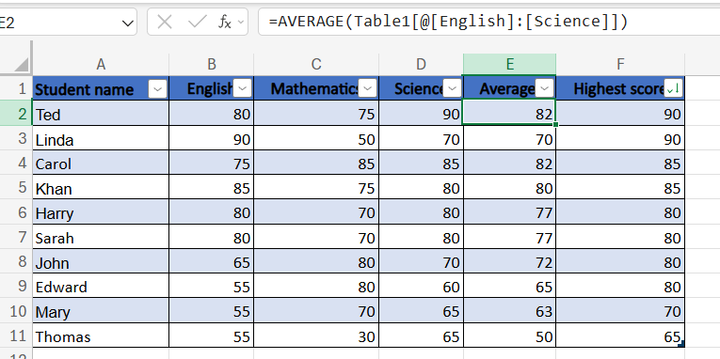  3) Using the =MAX fucntion, tell me what the students highest score was in column F. 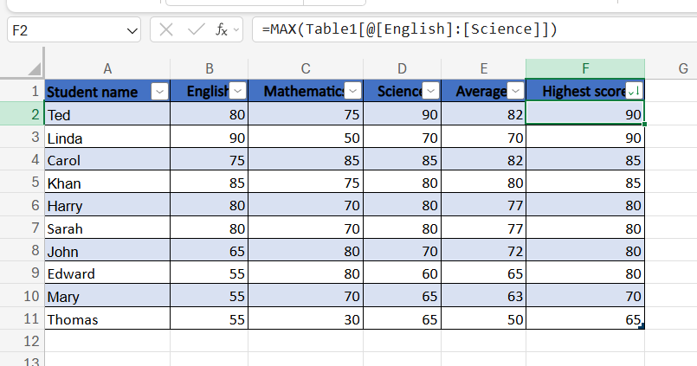  4) Apply filter and sorting to show the best student in this classroom by average. 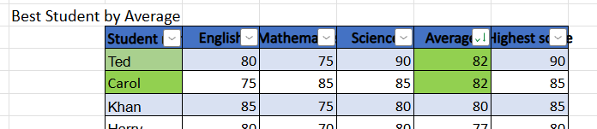  5) Apply filter and sorting to show the best student in this classroom by highest score. 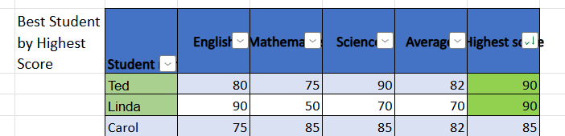  6) Use conditional formatting to clearly identify the highest and lowest average scores 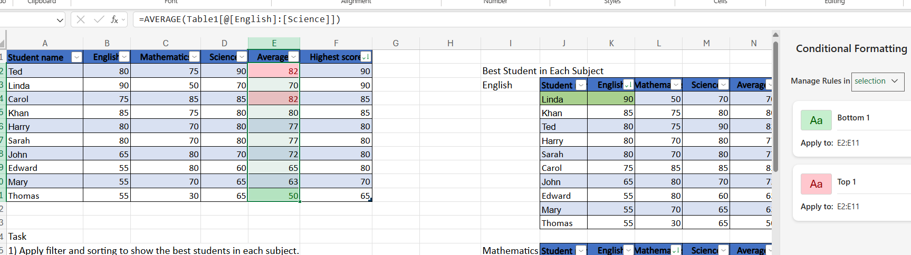

Day 2: Task 3

Using the skills developed today, have some fun with the data set you have imported. Paste your work below and enjoy!

Print screen 1 | Pivot Table  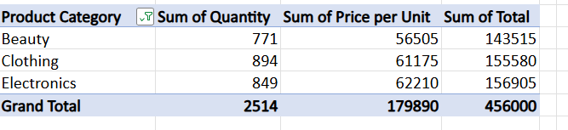  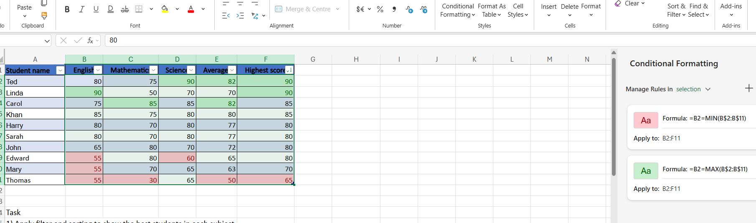

Day 3: Task 1

Please download the dataset ‘Day_3_Task_1_Bike_Sales_Pivot_Lab.xlsx’ from here.

The lab instructions can be found here. Do not worry if you do not complete the lab, just working with data and playing with the pivot table will be good experience.

Please paste your final pivot table below and complete the reflection questions:

Print screen 1 | 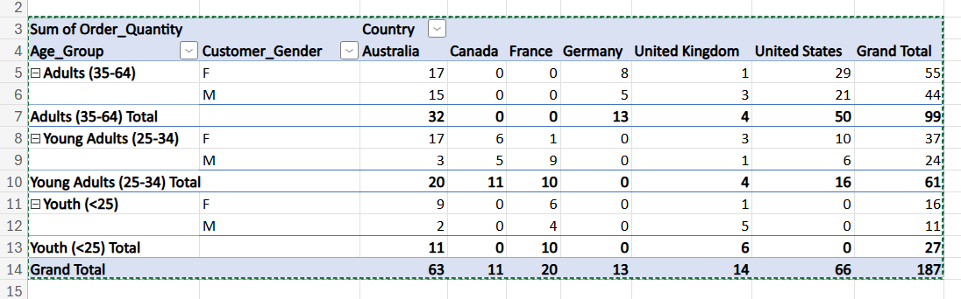
In which markets does Germany have customers? | 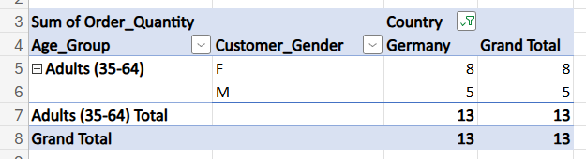Adults Segment
What country has sales in all markets? | Australia, United Kingdom
What are the most profitable markets by country, age group, and gender? | USA-Adults-Female 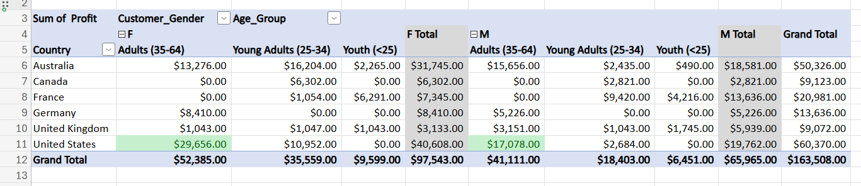Checked top value in Males and Females by conditional formatting. Adults-Female Segment in USA is most profitable.
Any other findings? | Australia Is the Most Balanced High-Volume Market.  Most of the sales worldwide is coming from adult’s segment dominated by Females. France is surprisingly different as young and young adult market is doing well.  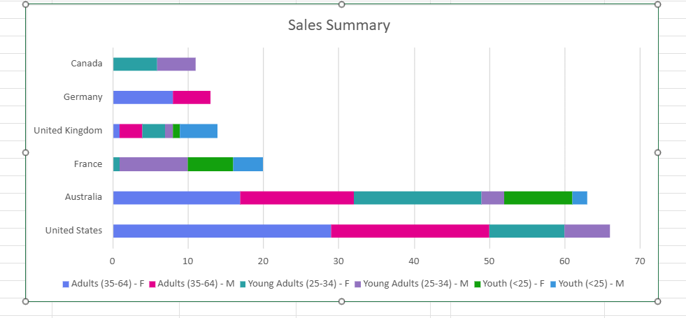

Day 3: Task 2

The dataset below tracks the sales performance of different products in various counties in England. Please paste the dataset into a blank Excel workbook. Your task is to:
- Create a Pivot Table to summarise the data by county and product.
- Use the SWITCH function to categorise products based on their sales volume.

Dataset:
County | Product | Sales Volume
Yorkshire | Laptops | 500
Yorkshire | Smartphones | 200
Cornwall | Laptops | 700
Cornwall | Printers | 400
Lancashire | Smartphones | 150
Lancashire | Laptops | 600
Essex | Printers | 800
Essex | Smartphones | 300
Durham | Laptops | 250
Durham | Printers | 300
Greater Manchester | Smartphones | 600
Greater Manchester | Laptops | 400

Step 1: Create a Pivot Table
- Select the dataset (columns A to C).
- Insert a Pivot Table to summarise the data by County in the rows and Products in the columns. Use Sales Volume as the value to be summarised.

Step 2: Use the SWITCH Function
In a new column next to your data, use the SWITCH function to categorise products based on Sales Volume as follows:
  - For sales greater than 600: "High"
  - For sales between 300 and 600: "Medium"
  - For sales less than 300: "Low"
SWITCH Function Example:
=SWITCH(TRUE, C2 > 600, "High", C2 >= 300, "Medium", "Low")
- Apply this formula to each row, and check if the products are categorised correctly.
- In ‘Sales Volume’ you need to remove the space after each amount
- Confirm the data type is numerical

Submission:
- A completed Pivot Table summarising sales by county and product.
- A new column in the dataset categorising products by sales volume using the SWITCH function.
  - Please paste your completed work below

Print screen 1 | 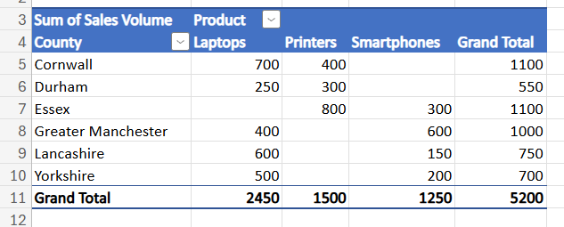  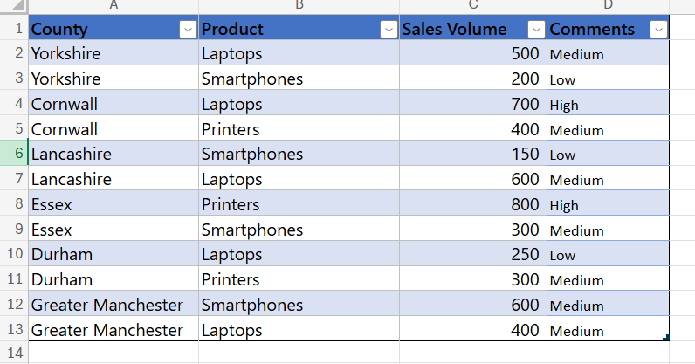

Day 3: Task 3

Please download the dataset ‘Day_3_Task_3_Bike_Sales_Visualisations_Lab.xlsx’ from here.

The lab instructions can be found here. Do not worry if you do not complete the lab, just working with data and playing with the charts will be good experience.

Please paste your results below:

Print screen 1 | 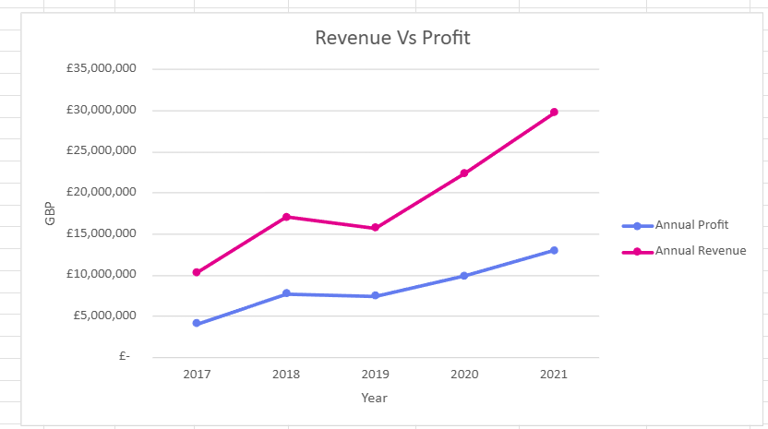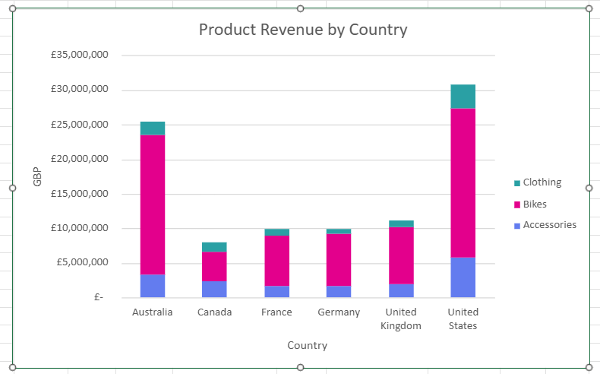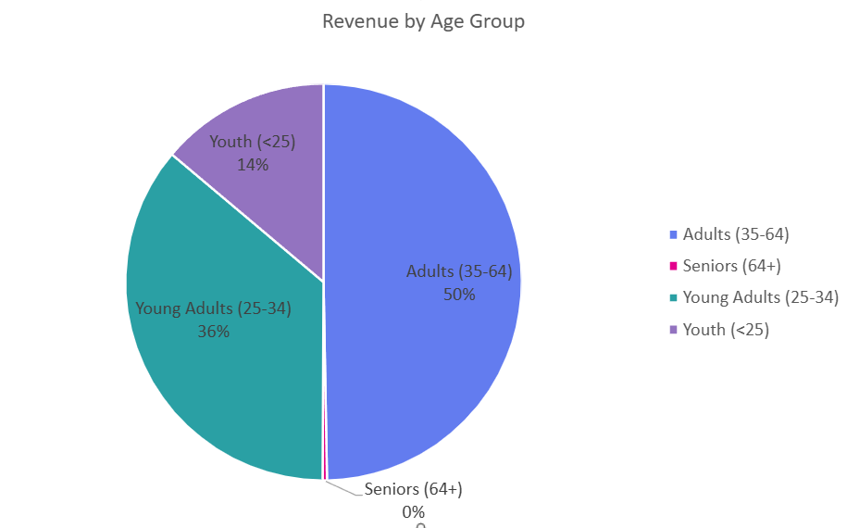

Day 4: Task 1

You have been asked to deliver your analysis findings to the board of directors, within your analysis you have identified that customers are leaving your company at the 12-month point, this is typically when they receive their renewal price.

Conduct research and complete the below questions:

How would you prepare for the delivery? | - Understand the audience/Stakeholders: Board members focus on financial impact, risk, and strategic decisions — not technical detail.  - Clarify the objective: The goal is to explain why churn spikes at 12 months and what actions will reduce it.  - Validate insights: Double-check data accuracy, assumptions, and methodology.  - Create a clear narrative:  Problem (12-month churn spike)  Evidence  Business impact  Recommendations  - Prepare an executive summary: One slide or one page with key takeaways.  - Rehearse: Practice timing, anticipate questions, and prepare backup slides.
What tools would you use for the delivery? | - Presentation: Microsoft PowerPoint or Google Slides  - Data visualisation: Tableau or Power BI  - Supporting analysis: Excel or Python (if needed)  - Meeting delivery: Teams / Zoom (if virtual)
What is prospecting and why would you complete this before your delivery? | Prospecting is the process of researching stakeholders to understand their priorities, concerns, and expectations.  Why do it before presenting to the board:  Helps tailor the message to what matters most (revenue, risk, growth)  Anticipates objections and questions  Aligns recommendations with company strategy  Builds credibility and trust
Tell me best practices for public speaking and providing updates to senior leaders
What will you show the board in your delivery?
How will you articulate the changes that are needed?
Provide a list of online resources and videos that will support your preparation for public speaking
Evaluate tools that provide visualisation.

Tell me what they are.

Tell me what you would choose when delivering your presentation and why

Course Notes

It is recommended to take notes from the course, use the space below to do so, or use the revision guide shared with the class:

Additional Information

We have included a range of additional links to further resources and information that you may find useful, these can be found within your revision guide.

END OF WORKBOOK

Please check through your work thoroughly before submitting and update the table of contents if required.

Please send your completed work booklet to your trainer.

